XML parsing, Serialization & De-Serialization techniques.
To convert a XML data into busness object data type in IBM BPM we have two ways
1.By using xpath method of javascript api
2.By serilizer method we can do both the conversions i.e. Serilization and Deserilization

By using xpath method of javascript api:
we can convert a simple xml data into BO type.
Let we use a XML data like
<customer>
<name>Ravi</name>
<age>23</age>
<sal>2151.214</sal>
</customer>

we need to convert this data into business object type

Step 1:
Create a Heritage human service, so that we can view the BO data on the screen.

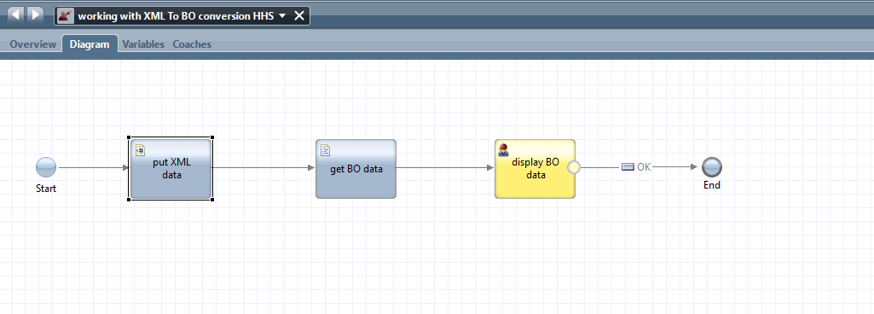
Step 2:
add two variables one input xml element of XMLElement type and one Output variable of BO type
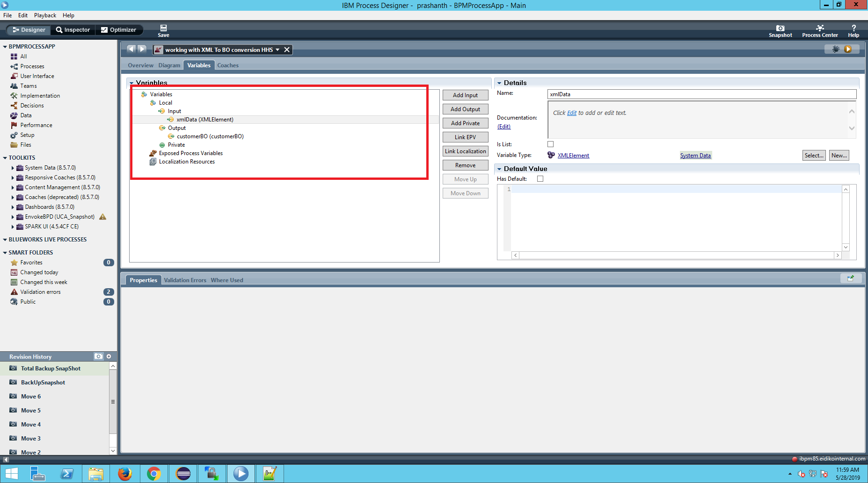

Step 3:
Drag a server scriptlet component from the pallete and map the input variable to the scriptlet.
Add the XML code into it.

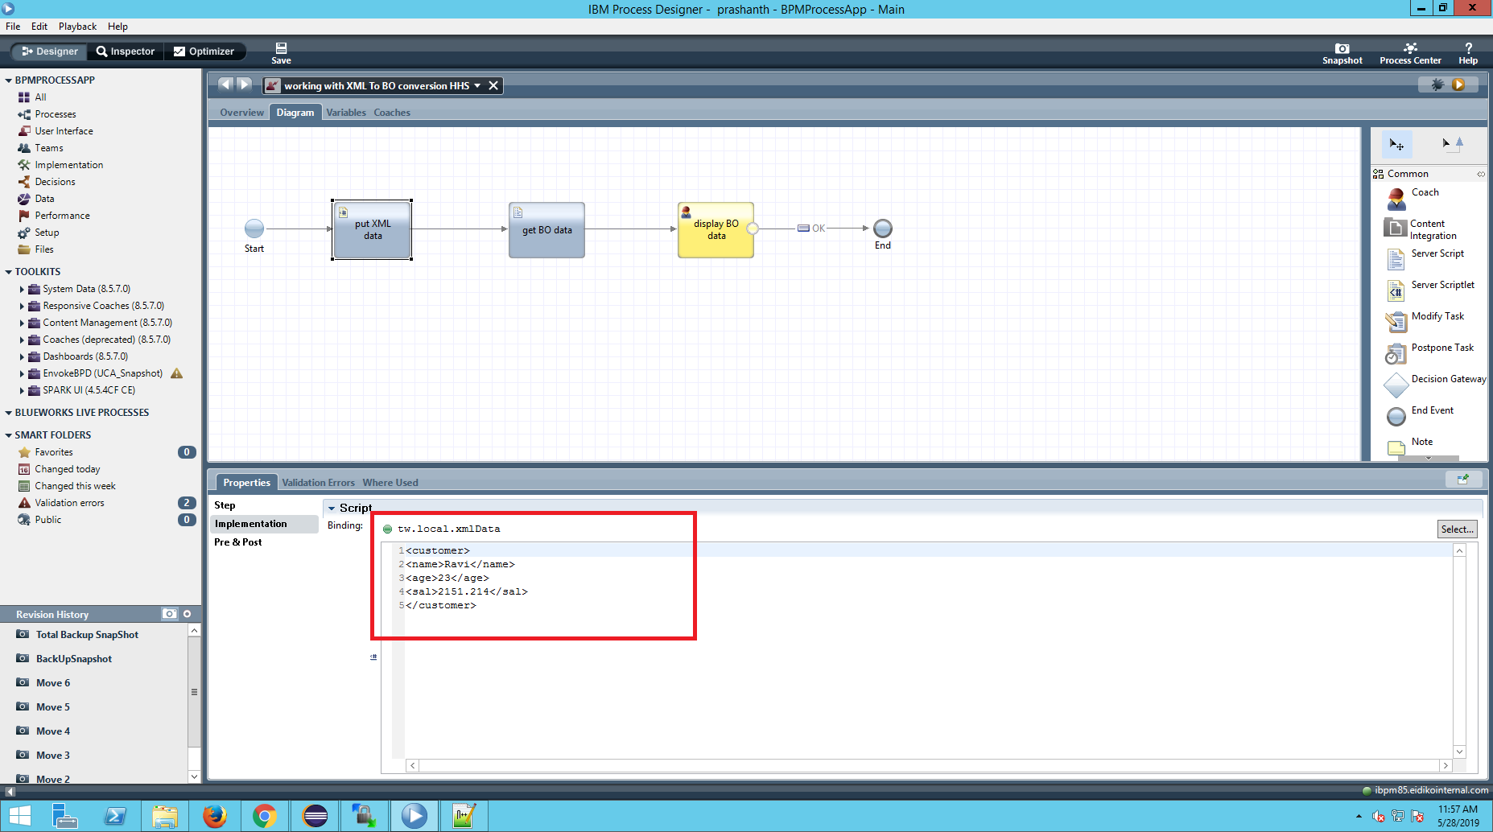

Step 4:
now add a server script component and add the code for conversion of xml data to Business data type.
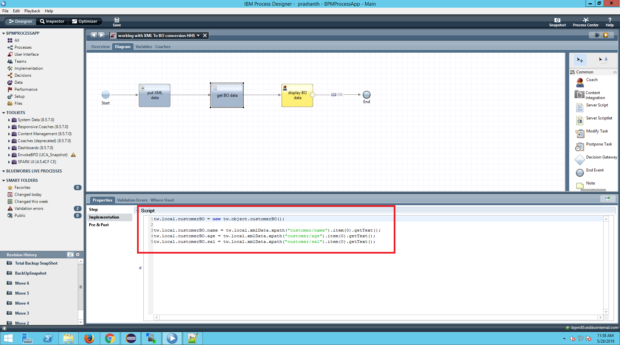

Add the following code in server script:

//instantiate the business object
tw.local.customer = new tw.object.customerBO();
tw.local.customer.name = tw.local.xmlData.xpath("customer/name").item(0).getText();
tw.local.customer.age = tw.local.xmlData.xpath("customer/age").item(0).getText();
tw.local.customer.sal = tw.local.xmlData.xpath("customer/sal").item(0).getText();

In the code xpath will get the path for the XML data i.e we need to give the variable name of that type.
item() defines the length of the value in the XML file.By default it starts with 0.This means if there is another xml fields along with thw customer then it will be 1.
getText() method will get the data present inthe XML parameter.

Step 5:
Now run the service in debug mode you can see the conversion.

Serilization and De-serilization techniques
serialization is the process of converting the XML data to teamworks objects.
Whenever we run some web service we will get data in the form of XML data which should be converted into Business object for the end users view.

IBM BPM system data toolkit has a method to convert the XML to BO
tw.system.serilizer

Conversion of XML data to Business Object Type Using Serilizer method

Step 1:

Create a service flow
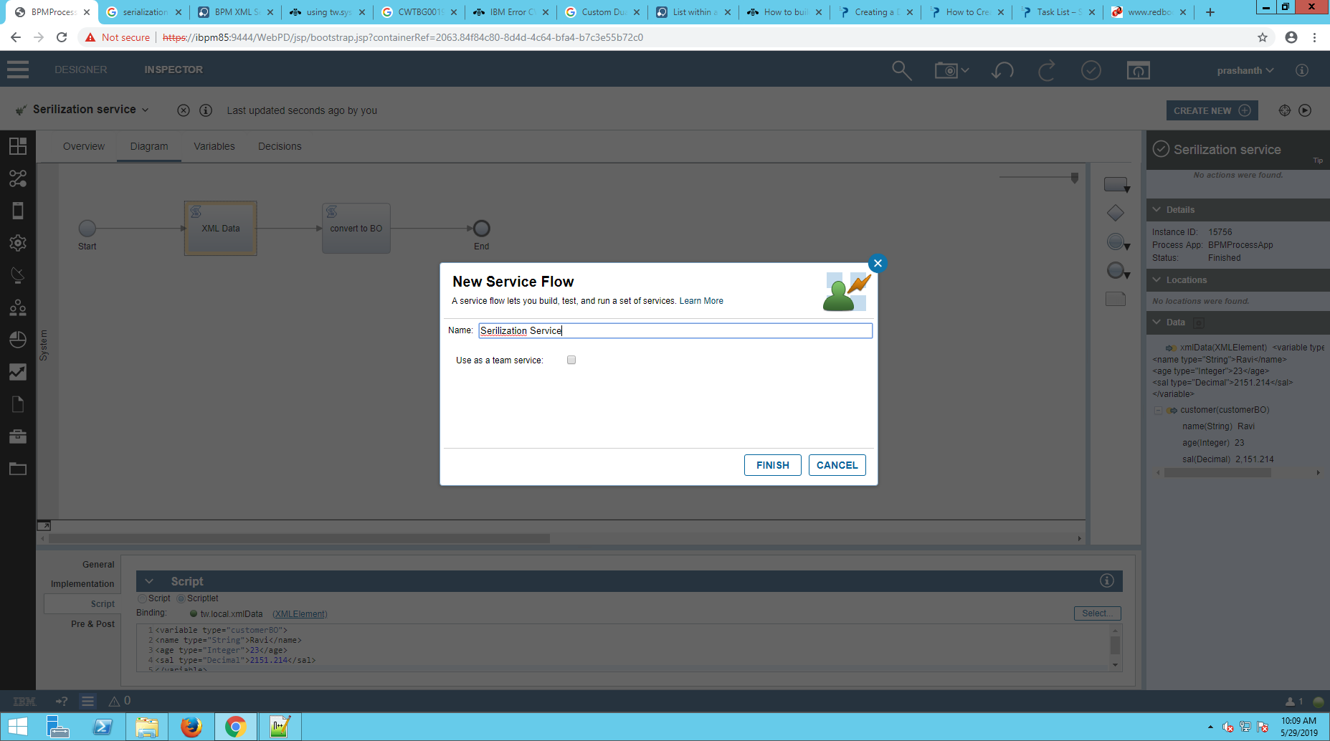

Step 2:
In variables Section declare one input variable and one output variable.
Input variable is of XMLElement type to store XML data.
Output variable of Business object type.

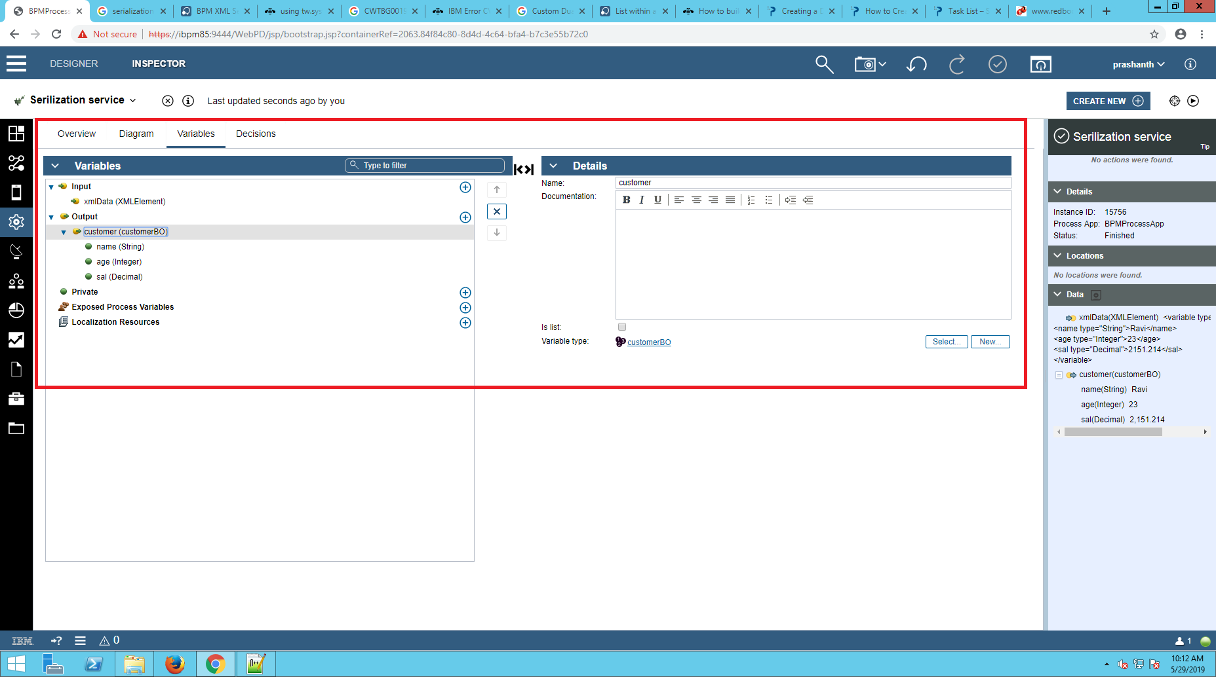
Step 3:
Drag two activites from the pallete and use first activity as server scriptlet to store the XML data.
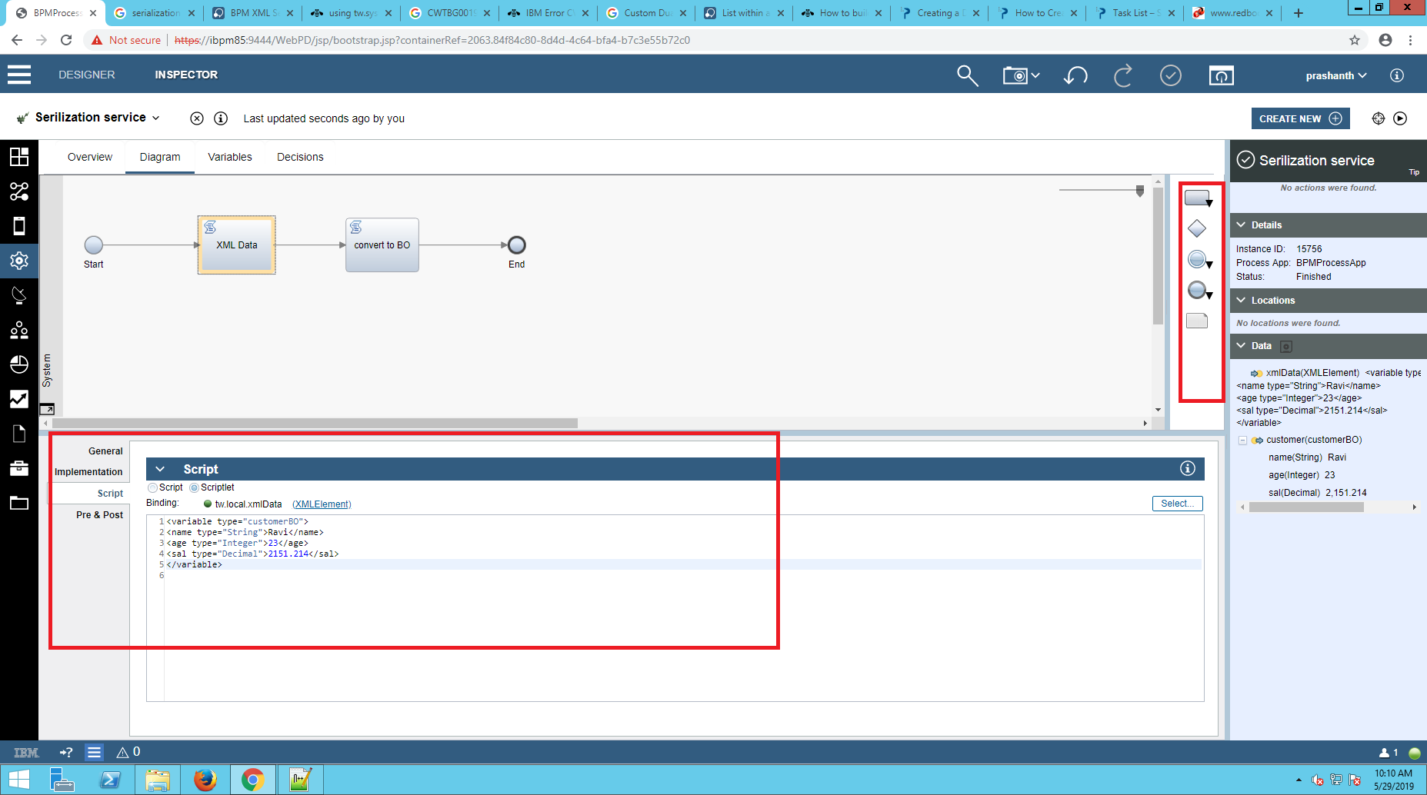
Add the following code of XML format of type customerBO.
<variable type="customerBO">
<name type="String">Ravi</name>
<age type="Integer">23</age>
<sal type="Decimal">2151.214</sal>
</variable>

Step 3:
Use the next activity as a server script to convert the XML data into Business object type.

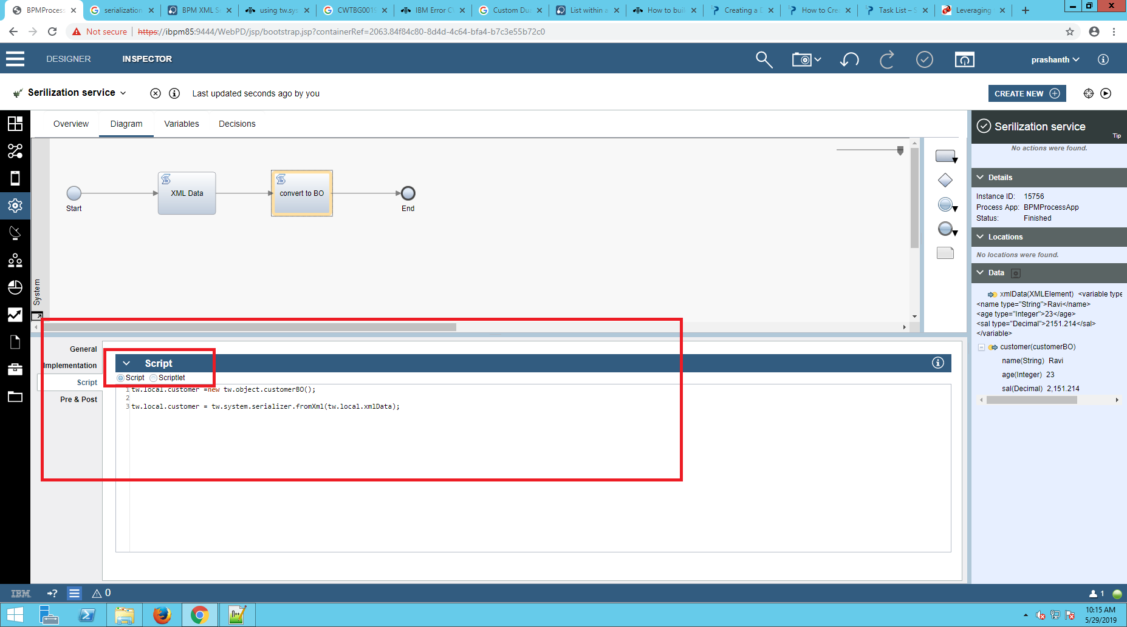
Add the code to convert xml data to BO type
tw.local.customer =new tw.object.customerBO();
//First line of code to instantiate the BO
tw.local.customer = tw.system.serializer.fromXml(tw.local.xmlData);
IBM BPM has a predefined SystemData toolkit It has a method to convert the XML to Bo type called as Serilizer.
tw.system.serializer
It has to methods
1.fromXml(variable) which returns object and provide the xml element.

2.toXml(variable) which returns XML element and provide Business object variable.

Step 4:
Run the service in debug mode you can see the XML data converted into Business object type.
Here the token is at first step Server Scriptlet.
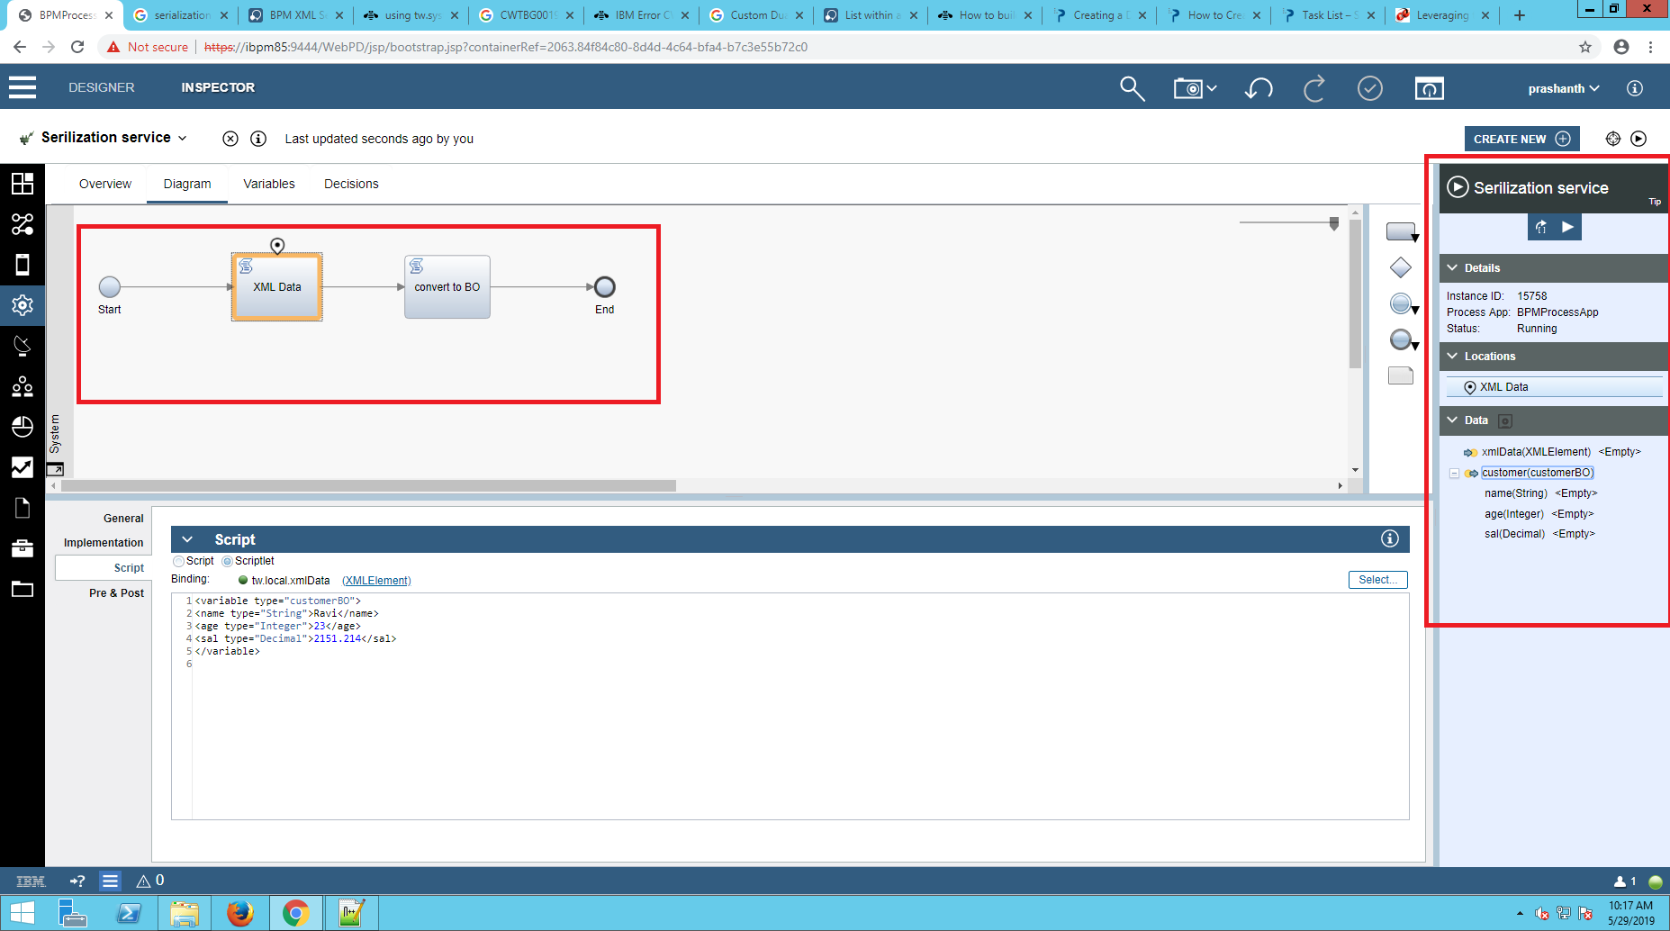

Next step follows,

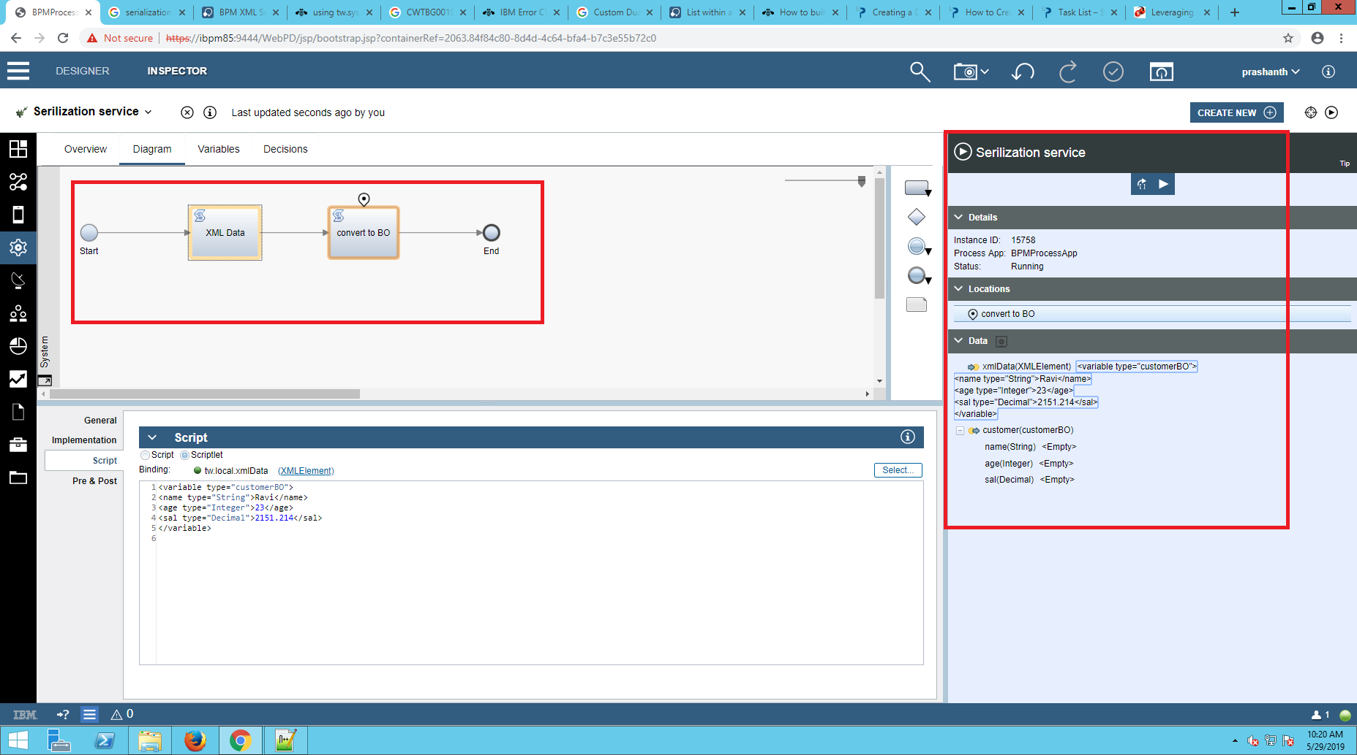

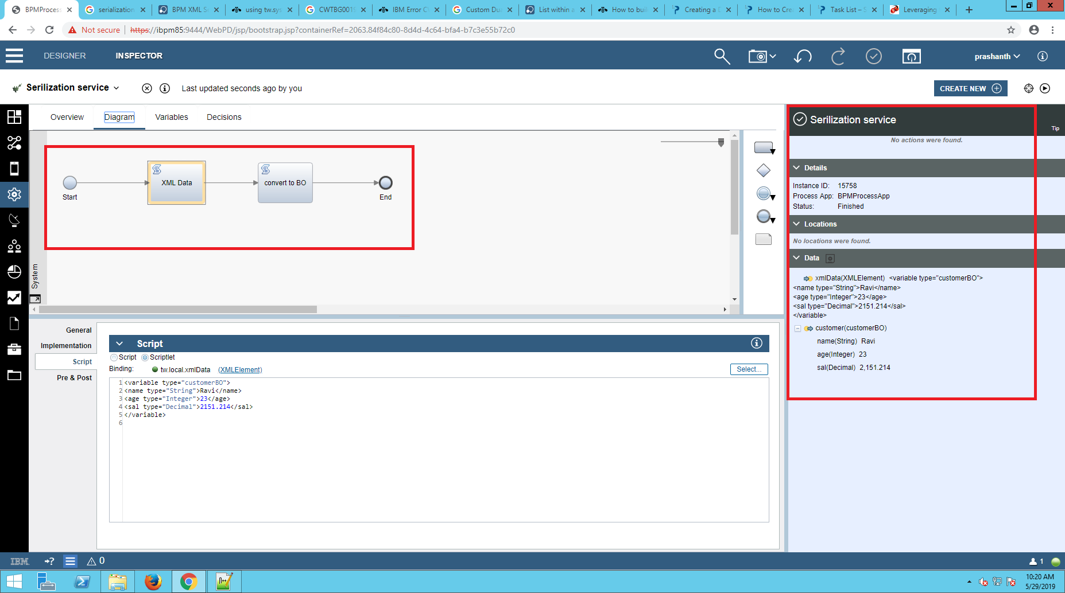
Finally the xml data is converted into business object.

Conversion of Business Object Type to XML data Using Serilizer method

Step 1:
Create a Service flow and name it.

Step 2:
In variable section add a input variable of business object type and a outpt variable of XMLElement to store the XML data that is converted.

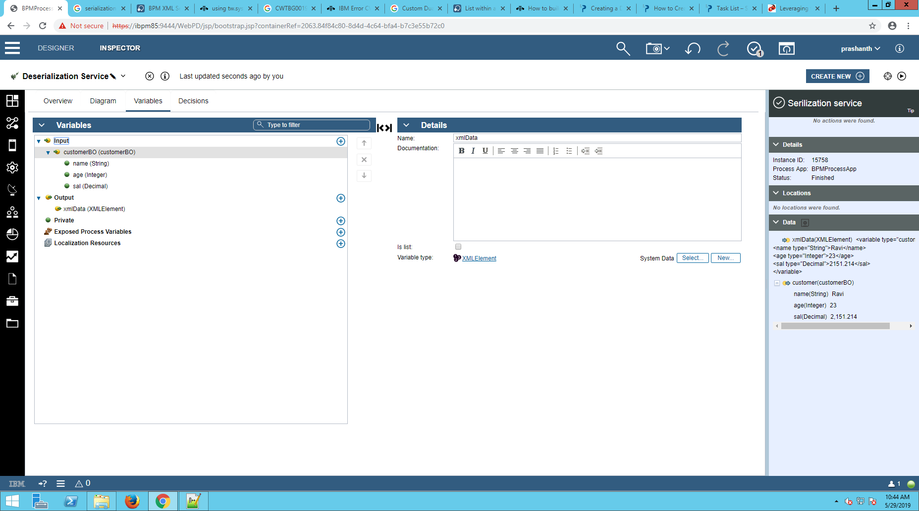

Step 3:
In the diagram section , drag two activities and use the first server script activity to initilize the Business Data.

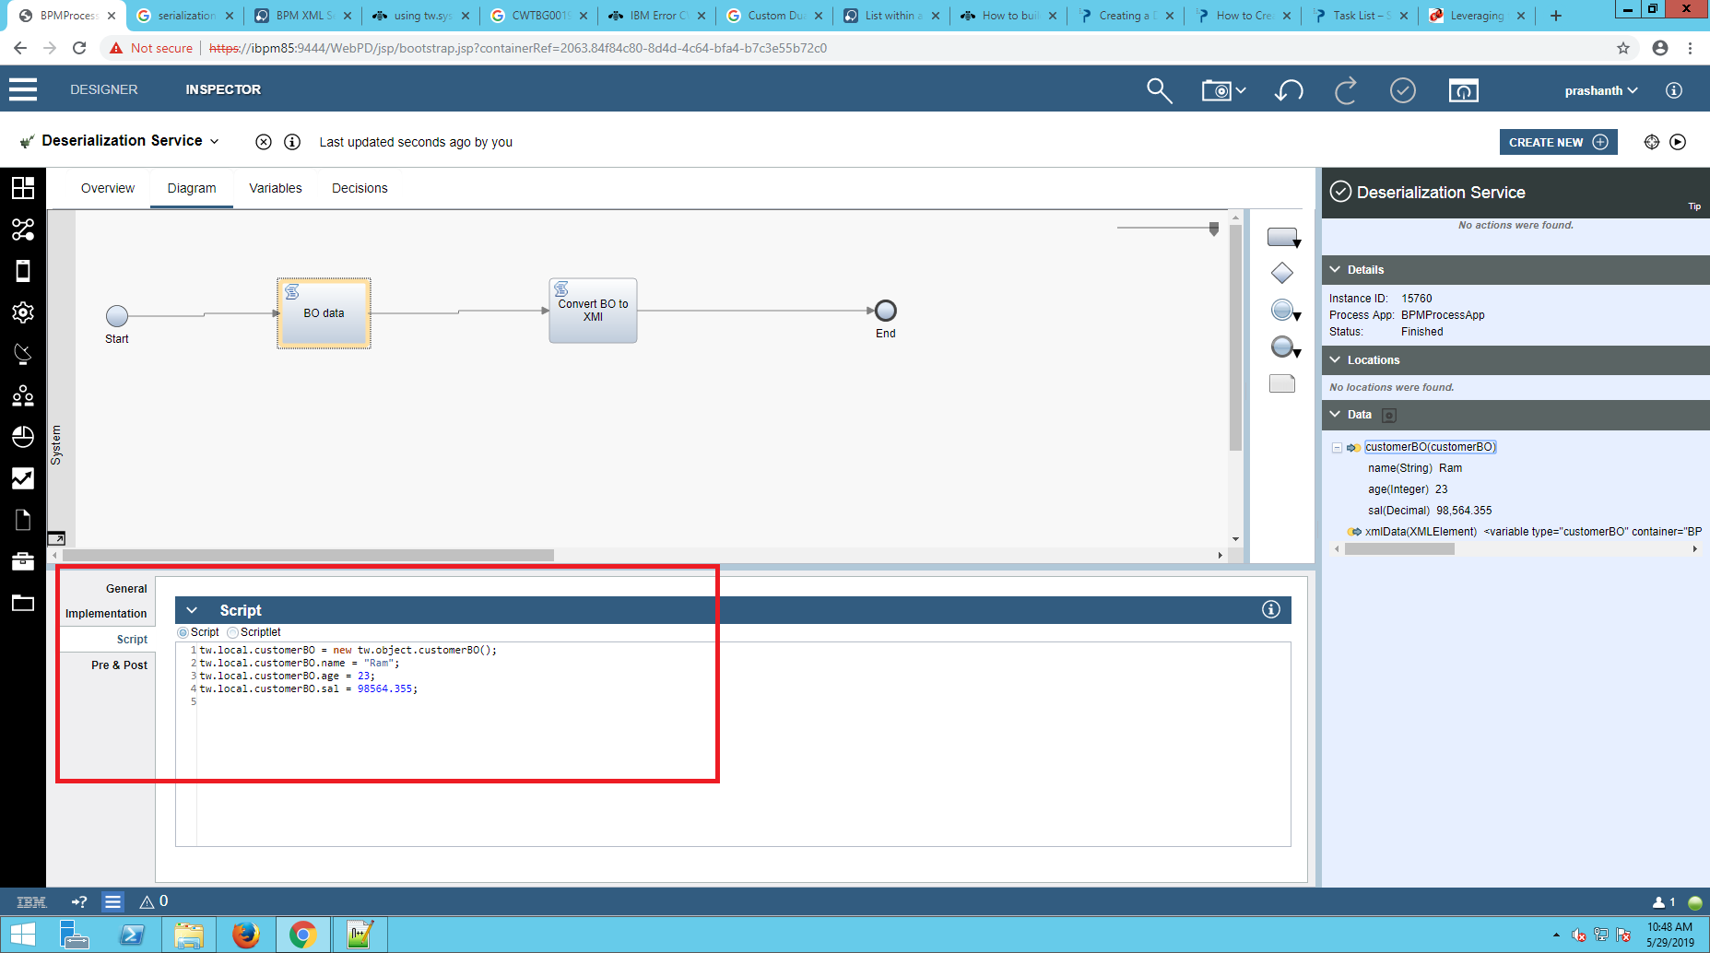
Add the code to initilize the Business Object,
tw.local.customerBO = new tw.object.customerBO();
tw.local.customerBO.name = "Ram";
tw.local.customerBO.age = 23;
tw.local.customerBO.sal = 98564.355;

Step 4:
In the next activity, write the code to convert the BO to XML data.
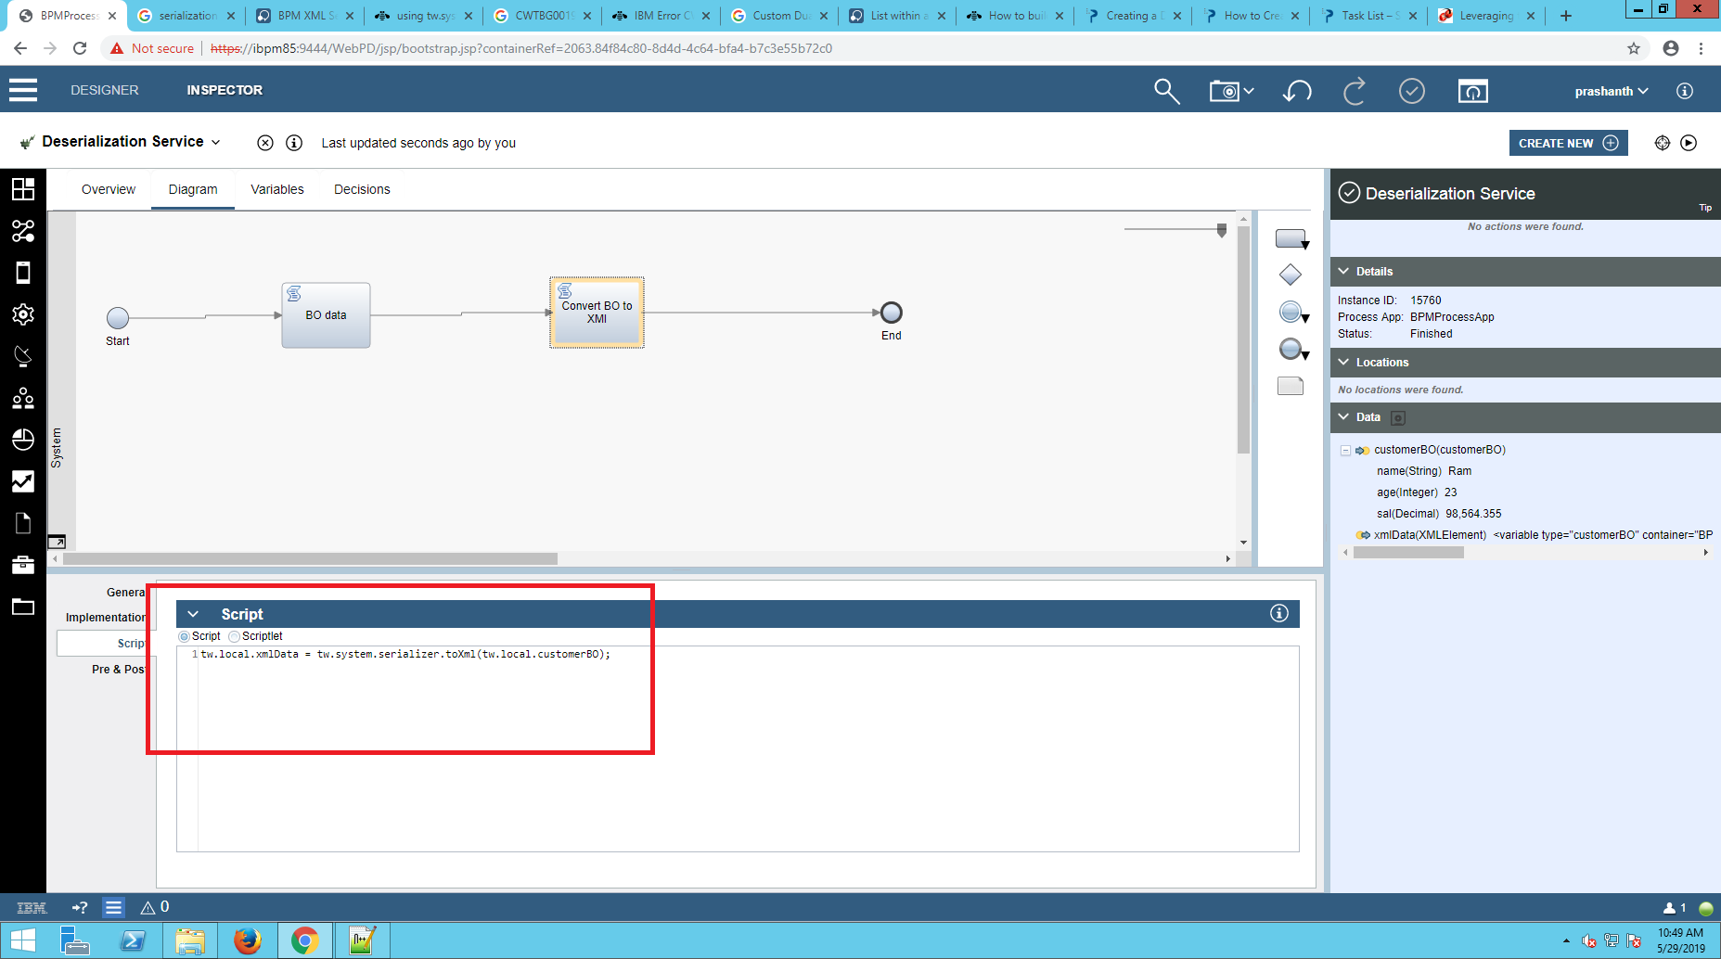

We use the same serilizer method to convert BO data to XML data but the method will be different.
We use the method, tw.system.serializer.toXml(variable) that returns the XML Element and takes input of BO type.

Add the code,
tw.local.xmlData = tw.system.serializer.toXml(tw.local.customerBO);

Step 5:Now run the service in Debug mode,

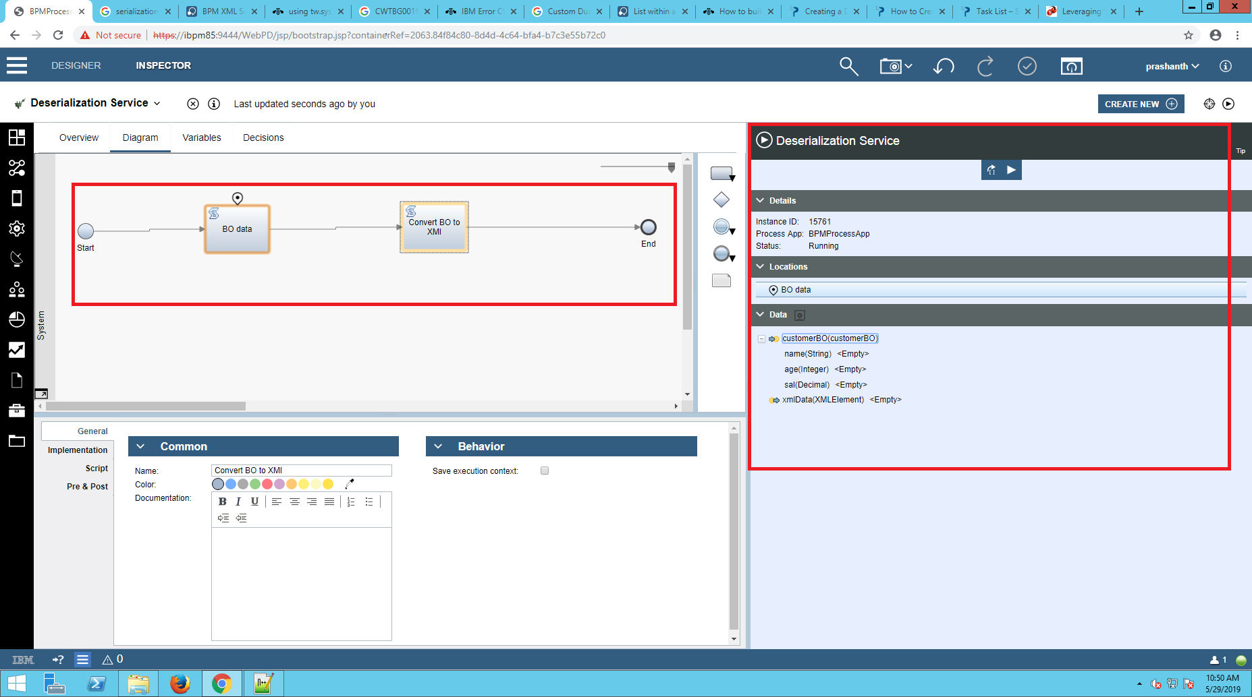
Now the token will be in the second script and now the BO data will be converted to Xml type.

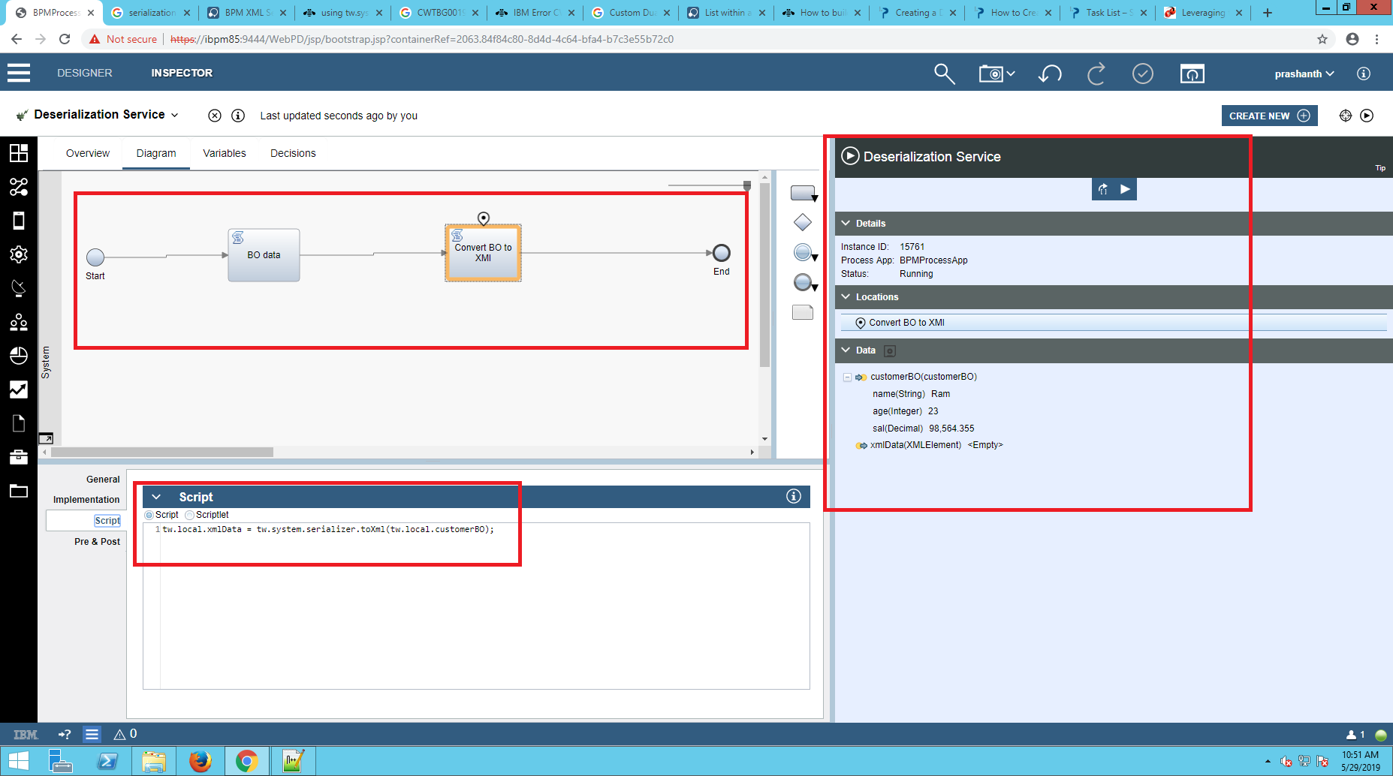
The converted XML data looks as follows,
